Of Cannibal Eunuchs and Waggon Hunters: The Swindle Story around the World
Christopher Rea

October 19, 2017
Charles University
Why do collections of swindle stories appear at certain times and places? In China, for example, the swindle story has experienced bursts of popularity during the late Ming, the early Republican era, the early Mao era, and during the last 20 years. And comparable works exist around the world. What, for example, do Zhang Yingyu’s Book of Swindles (Ming China, 1617), Richard King’s The New Cheats of London Exposed (Georgian England, 1792), and P.T. Barnum’s The Humbugs of the World (Reconstruction-era United States, 1867) have in common—and how do they differ? Swindle stories, clearly, serve a double purpose: they teach techniques for navigating perilous social environments, and they entertain. But theirs authors tend to frame these narratives within a questionable claim: that ours is an age of unprecedented peril. Focusing on the example of China, this talk will highlight one thread running through literary history: connoisseurship of the swindler’s ingenuity.

The Age of Irreverence: A New History of Laughter in China
Christopher Rea

October 20, 2017
Charles University
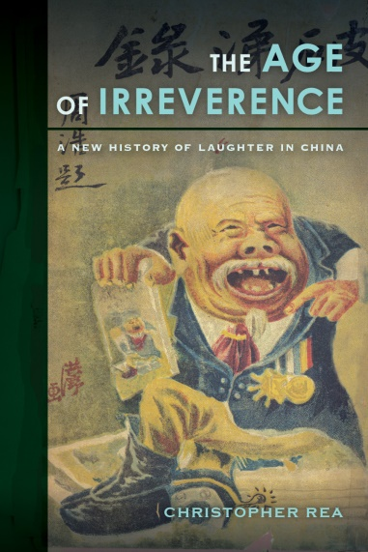
China's entry in modernity was not just traumatic, but uproarious. As the Qing last dynasty fell, prominent writers compiled jokes to form collections called “histories of laughter.” In the first years of the republic, novelists, essayists, and illustrators used humorous allegories to make veiled critiques of the new government. Yet political and cultural discussion repeatedly erupted into invective, with critics gleefully jeering rivals in public. Farceurs drew followings in the popular press, promoting a culture of buffoonery. These expressions of hilarity proved so offensive to high-brow writers that they launched a campaign in the 1930s to displace old forms of mirth with a new one they called youmo (humor). What can we learn about history from those who laugh their way through it? Focusing on the case of China, this talk will discuss how political turmoil, new media, and other forces nurtured cultures of humor in a modernizing society, from the last days of empire to the digital age.

Christopher Rea is Associate Professor of Asian Studies and former Director of the Centre for Chinese Research at the University of British Columbia. He is author of The Age of Irreverence: A New History of Laughter in China (California, 2015), which won the 2017 Joseph Levenson Book Prize (post-1900 China). He is editor of China’s Literary Cosmopolitans: Qian Zhongshu, Yang Jiang, and the World of Letters (Brill, 2015) and Humans, Beasts, and Ghosts: Stories and Essays by Qian Zhongshu (Columbia, 2011); and co-editor of The Business of Culture: Cultural Entrepreneurs in China and Southeast Asia (UBC Press, 2015). His most recent book, translated with Bruce Rusk, is The Book of Swindles: Selections from a Late Ming Collection (Columbia, 2017); the original work, said to be China’s first collection of stories about fraud, celebrates its 400th anniversary in 2017.
http://asia.ubc.ca/persons/christopher-rea/

